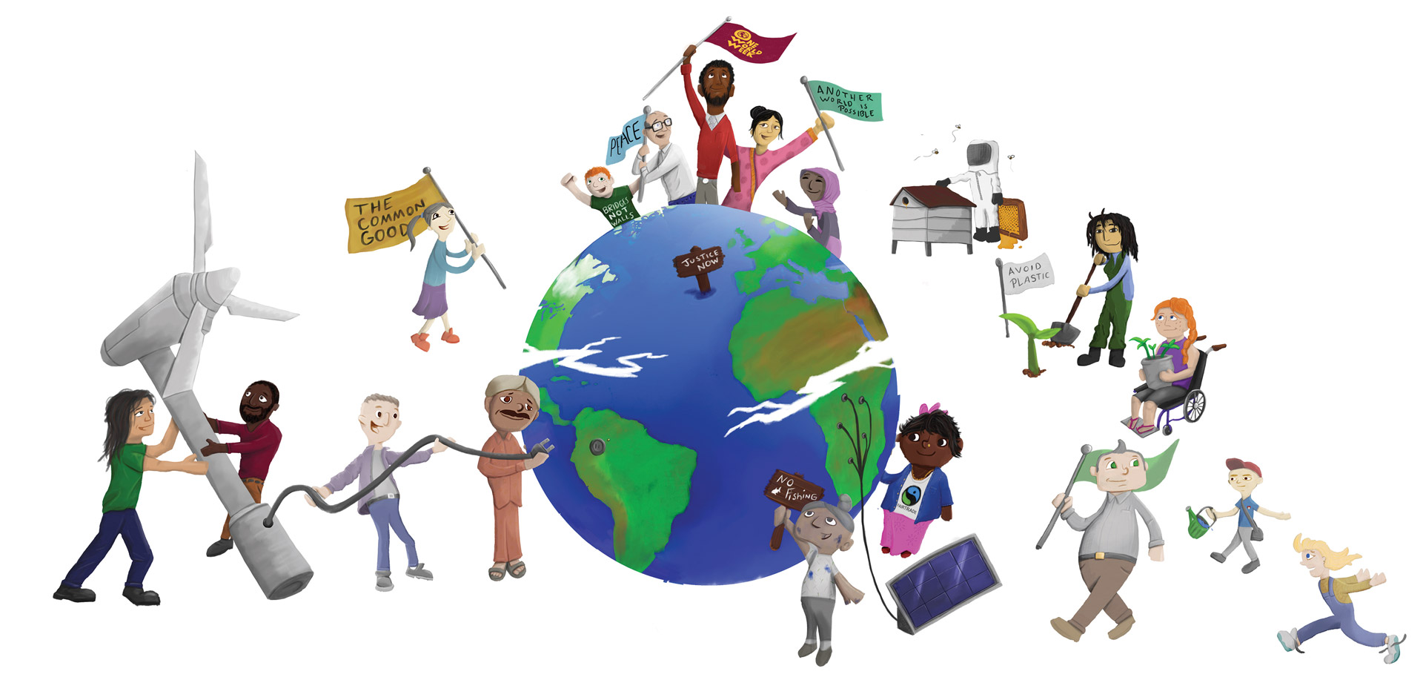
Illustration by www.webber-design.com

The World is Changing – How About Us?
One World Week Quiz
- How many disposable coffee cups do we throw away in Britain each year?
- 500,000 1,000,000 1 billion 2.5 billion

- A truck load of plastic waste is dumped in the sea every
- Second ..minute hour day

- The UN has estimated the number of plastic fragments in the sea at
- 1 trillion 5 trillion 28 trillion 51 trillion

- What percentage of plastic bottles are recycled?
- 1% 7% 16% 23%

- How much of the food we produce is lost or wasted?
- 13% 23% 33% 42%

- How much have sea levels risen over the last 100 years?
- 3 cm 8 cm 11 cm 17cm

- Where does the majority of our plastic waste end up?
- Oceans landfill recycled burned for energy

- What percentage of greenhouse gas emissions (caused by human activity) does livestock production contribute? Is it:
- 3.5% 7% 14.5 % 26%

- What percentage of the planet’s croplands is used to produce livestock feed?^{i}
- 11% 22% 33% 44%

- What percentage of the Planet’s land (ice free) is used for grazing livestock?^{i}
- 14% 26% 38% 50%

- Rainforest is being cut down to develop land to raise livestock. In 2016 rainforest the size of a hundred football pitches was being cut down every:
- hour day week month

- Deforestation contributes to global carbon emissions –because rainforests play a vital role in absorbing carbon emitted by humans and release all their stored carbon when they are cut down and burnt or left to rot. What percentage of all carbon dioxide emissions, caused by human activity, are contributed by deforestation?
- 5% 10% 20% 40%

- “Tropical forests now emit more carbon than they capture, due to deforestation and degradation, so that they are no longer a carbon ‘sink’”
- TRUE or FALSE ?

- What percentage of the UK population are Vegan?
- 2% 4% 7% 11%

- Research - collected from a consumer panel of 30,000 households – revealed that, in the 12 weeks to the end of January 2018, the percentage of people’s evening meals that contained no meat or fish was:
- 7% 15% 22% 29%

- How many plastic straws are used in the USA each day?
- 500,000 13 million 30 million 500 million

- How many meals are wasted each week by the average British family?
- 2 3 5 6

- Two thirds of the earth’s breathable oxygen comes from
- Forests lakes forests oceans

- How much water is used to produce a one litre bottle of water?
- One two three four litres

- According to the Ellen MacArthur Trust, plastic will outweigh fish in the ocean by
- 2050 2080 2100 2150

- The World Wildlife Fund reckons we are losing species at an alarming rate each year. At least
- 1,000 3,000 10.000 20,000 a year

- How many species of British bee are at risk of extinction?
- 3 7 15 35

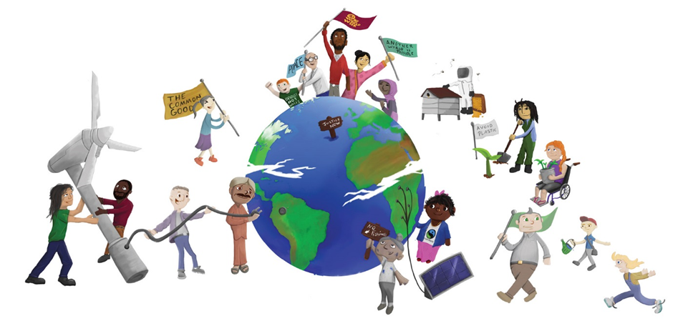



The World is Changing – How About Us?
One World Week Quiz - Answers

- 2.5 billion
- Minute
- 51 trillion
- 7%
- 33%
- 17 cm
- Oceans
- 14.5%
- 33%
- 26%
- Hour
- 10%
- True
- 7%
- 29%
- 500 million
- 6
- Oceans
- Three litres
- 2050
- 10,000
- 35

Sources
Earth Day - https://www.earthday.org/
Friends of the Earth - https://friendsoftheearth.uk/about-us/our-campaigns
Meat Free Monday - https://www.meatfreemondays.com/
World Wildlife Trust- http://wwf.panda.org/

